### II. Reporting - paraphrase, summary, plagiarism

1. Read the following phrases and decide which are TRUE statements about summarising and/or paraphrasing

a. Paraphrasing is an important academic skill in order to avoid the risk of plagiarism.

b. Partially changing the wording of a text so that is seems different from the original text is an effective summarising technique.

c. One should summarize when what you want from the source material is the idea expressed and not the specific language.

d. You should paraphrase to change the emphasis of information to match your own arguments.

Language work

**Paraphrasing** and **Summarising** skills can help you in your studies for different purposes such as:

⮚ preparing for exams  
⮚ taking notes on your readings  
⮚ collecting and condensing information for writing research papers  
⮚ integrating sources into your writing

⮚ refer to work that leads up to the work you are now doing

⮚ give examples of several points of view on a subject

⮚ provide support for claims and add credibility to your writing

**Paraphrasing\*** is an important skill to use while supporting your ideas. Paraphrasing is writing someone else’s ideas in your own words at roughly the same level of detail, without changing the meaning.  A paraphrase must be attributed to the original source (you must quote the original work).

**Summarising** moves much further than paraphrase from point-by-point translation. When you summarize a passage, you need first to absorb the meaning and then to capture in your own words only the main points from the original passage. A summary is necessarily shorter than a paraphrase. Once again, it is necessary to attribute summarized ideas to the original source.

|  |
| --- |
| **\*** **Note** Automatically identifying paraphrases and non-paraphrases has proven useful for a wide range of natural language processing (NLP) applications, including question answering, semantic parsing, information extraction, machine translation, textual entailment, and semantic textual similarity. |

2. Consider the following sample texts and comment whether they are:

1. a source text and a paraphrase
2. a source text and a summary
3. completely equivalent summaries
4. completely equivalent paraphrases
5. roughly equivalent summaries
6. roughly equivalent paraphrases

Sample A: “free software is software that is freely available and allows the users to access the source code”  
Sample B: “typically free software refers to a type of software where source code is made freely available”

**Steps for writing an effective paraphrase:**

1. Read and understand the text.

2. Change the words/phrases with their synonyms.

3. Change the structure of the original (you might consider possible **synonyms for the source vocabulary** and **changing the part of speech** (change nouns to verbs, adjectives to adverbs, etc., break up long sentences, combine short sentences, for instance).

* Do not try paraphrase **specialized vocabulary** or **technical terms**.
* You can borrow **standard phraseology** of your field and **skeletal phrases** when appropriate, but not special expressions or phrases in their entirety without at least using quotations marks.

Eg. *The increasing popularity of _________is attributed to_________.* The increasing popularity of Voice over Internet Protocol can be attributed to it slow cost.

4. Rewrite the original in your own words to avoid plagiarising.

5. Keep the meaning as it is.

6. Keep the text at approximately the same length as the original.

7. Remember to give in-text reference.

**Steps for writing an effective summary:**

1. Read the text carefully and make sure you fully understand the text

2. Identify the **central idea** and all the **main ideas**. Distinguish between main and subsidiary information.

3. Leave out minor details, examples, illustrations or explanations but keep the most important information that accurately represents all the major points of the original text.

4. Paraphrase the original text accurately in your own style by **preserving the original meaning of the text**.

* Do not include any personal opinions, interpretations, deductions or comments unless you are planning to do a critical review. Keep the text shorter than the original text (about 1/3 or 1⁄4 of the original).

5. Present the important points by focusing on **old-to-new information flow** and make sure the ideas flow logically by meaningfully combining the sentences with the help of **transitions**.

6. Check **clarity** and **conciseness** of the summary for a reader who has not seen the original text.

7. Remember to give in-text reference.

**Plagiarism**

**1. Study the following examples of an original text vs a plagiarised version, draw a comparison between the two text samples and formulate appropriate comments:**

|  |  |
| --- | --- |
| Original | Plagiarised version |
| "How important is our power of nonanalytical thought to the practice of science? It's the most important thing we have, declares the Princeton physicist historian Thomas Kuhn who argues that major breakthroughs occur only after scientists finally concede that certain physical phenomena cannot be explained by extending the logic of old theories. Consider the belief that the sun and the planets move around the earth, which reigned prior to 1500. This idea served nicely for a number of centuries, but then became too cumbersome to describe the motions of heavenly bodies. So the Polish astronomer Copernicus invented a new reality that was based on a totally different `paradigm' or model--that the earth and planets move around the sun" (Hoover, 124). | Non-analytic thought is considered very important to the practice of science by Princeton physicist historian Thomas Kuhn who claims that major breakthroughs happen only when scientists finally concede that some physical phenomena defy explanation by extending the logic of old theories. One idea which served nicely for many centuries but then became too cumbersome was the belief that the sun and planets revolved around the earth. This was held prior to 1500 until Copernicus invented a new reality: the earth and planets move around the sun. |

Taken from Cough (2000), *Plagiarism in natural and programming languages: an overview of current tools and technologies*, <https://ir.shef.ac.uk/cloughie/papers/plagiarism2000.pdf>.

***Why is this plagiarism?***

The writer has used Hoover's exact words without enclosing them in quotation marks. The lack of quotation marks, reference and repeated use of exact wording and sentence structure that make this plagiarism S/he has only substituted synonyms here and there. Even though Hoover is credited with a citation, this would be considered plagiarism.

**2. Also compare the following sample texts (A-B) and identify: (a) the original text (b) the paraphrase (c) plagiarism**

|  |  |
| --- | --- |
| Sample A  The creation of an overall design for a complete computer system is the responsibility of a systems analyst; whereas, the implementation of the design plan is often the duty of the computer programmer. | Sample B  The systems analyst designs the entire computer system, and the computer programmer makes the proposed system work. |

**4. Paraphrase the following paragraph using *because/lead to or due to*. Before writing, break the task into important points, relationships, transitions, and synonyms.**

. . . nondriving-related *devices,* such as mobile phones, and, more recently, navigation systems, divert drivers' attention increasingly more away from the primary sources of information necessary for safe operation of the vehicle: the road and other road users.

|  |  |  |  |
| --- | --- | --- | --- |
| important points | relationships | transitions | synonyms |
|  | * Cause - effect | because | *divert* -+ *distract, sidetrack, take away,* |

**5. Work in groups and summarise the advice in each text in one sentence. Include the sentences in the table below.**

Group A reads texts 1 to 3.

Group B reads texts 4 to 6.

Group C reads texts 7 to 9.

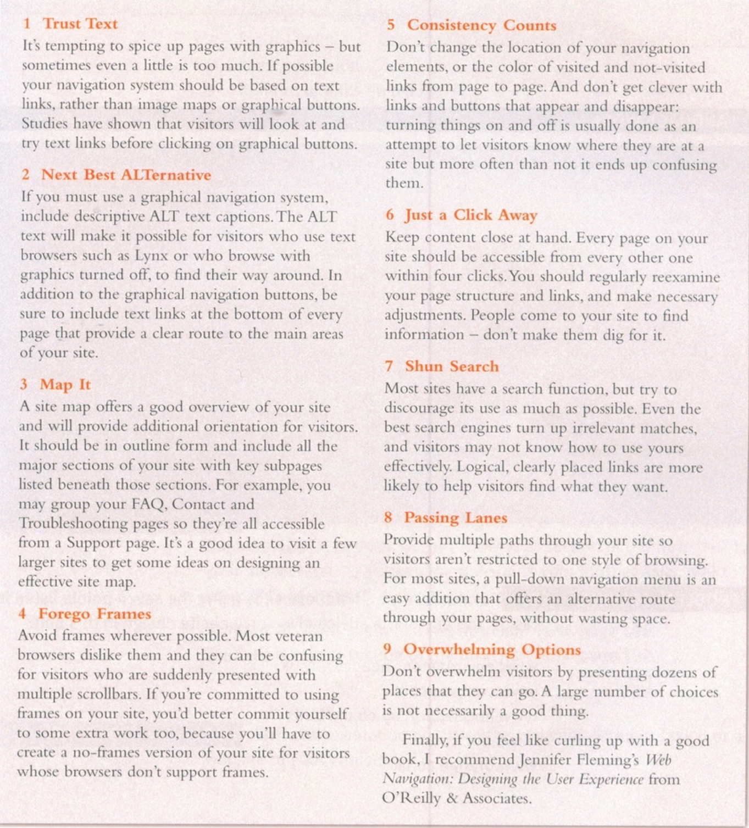

**Complete this table summarising the whole text:**

|  |  |
| --- | --- |
| *Text* | *Advice:* |
| *1.* |  |
| *2.* |  |
| *3.* |  |
| *4.* |  |
| *5.* |  |
| *6.* |  |
| *7.* |  |
| *8.* |  |
| *9.* |  |